Cleaning performed
- Missing values
  - Numerical columns → median imputation
  - Categorical columns → mode imputation
  - Final_Amount → calculated as Order_Value - Discount_Applied
- Outliers
  - Applied IQR capping to:
    - Delivery_Time_Min
    - Order_Value
- Invalid values
  - Restaurant_Rating > 5 → corrected and imputed
  - Delivery_Rating outside 1–5 → corrected
  - Negative Profit_Margin → treated as invalid and imputed
- Categorical standardization
  - Removed extra spaces
  - Standardized values such as Male, Female, Delivered, Cancelled, Weekday, Weekend
- Logical consistency
  - Cancelled orders → Delivery_Rating removed/imputed appropriately
  - Delivered orders → Cancellation_Reason cleared
  - Peak_Hour recalculated from order time where available

Step 4: Exploratory Data Analysis (EDA)
EDA is performed to uncover hidden patterns and trends:
- Distribution of order values and delivery time
- City-wise and cuisine-wise order analysis
- Weekend vs weekday demand
- Distance vs delivery delay relationship
- Cancellation reasons analysis
- Correlation analysis among numeric features

  - Distribution of Order Values and Delivery Time

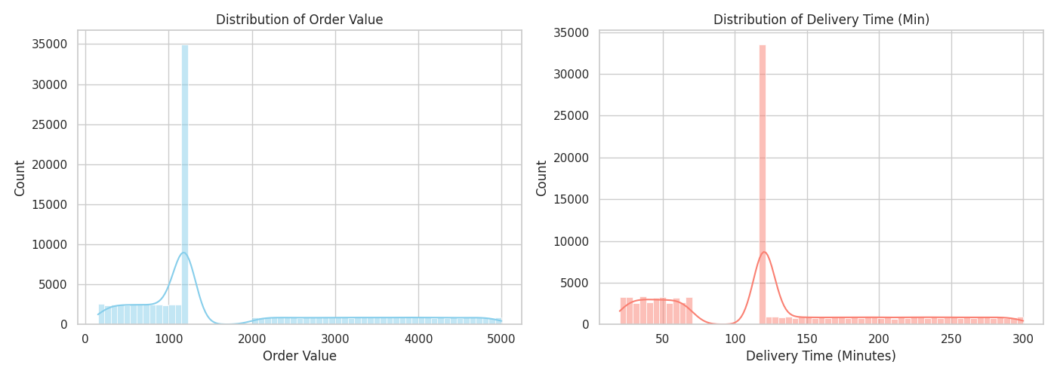
- Order Value: Ranges from ₹150.0 to ₹5,000.0, with a mean of ₹1,786.94 and a median of ₹1,197.00. There is a noticeable clustering around median imputed values (~₹1,197), followed by a uniform spread up to ₹5,000.
- Delivery Time: Averages 124.98 minutes (median: 120 minutes), ranging from 20 to 300 minutes. Imputation effects show heavy density near the 120-minute mark, alongside uniform distribution segments across faster and slower delivery windows.

  - City-Wise and Cuisine-Wise Order Analysis

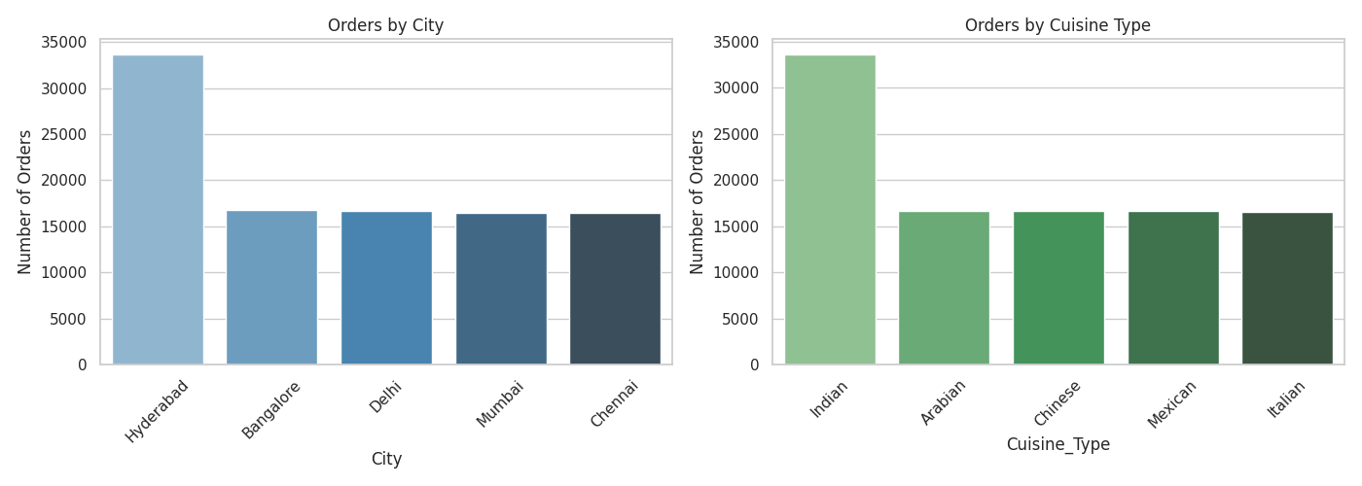
- City Distribution: Hyderabad dominates order volume at 33,610 orders (~33.6%), while Bangalore (16,732), Delhi (16,695), Mumbai (16,493), and Chennai (16,470) maintain an almost equal ~16.5% market share each.
- Cuisine Distribution: Indian cuisine leads with 33,570 orders (~33.6%). The remaining cuisines—Arabian (16,658), Chinese (16,651), Mexican (16,602), and Italian (16,519)—are evenly distributed across the remaining ~66.4% volume.

  - Weekend vs. Weekday Demand

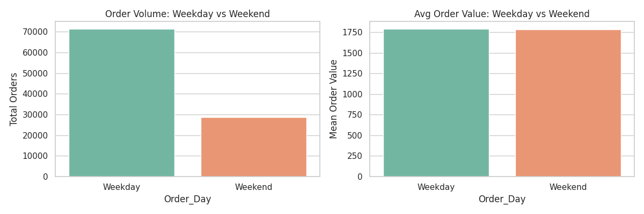
- Order Volume: Weekdays account for 71.37% (71,370 orders) of total volume compared to 28.63% (28,630 orders) on Weekends. This matches a standard 5:2 day proportion, indicating consistent daily demand.
- Average Order Value: Near-identical spending patterns between periods: ₹1,789.42 on Weekdays vs. ₹1,780.78 on Weekends.

  - Distance vs. Delivery Delay Relationship

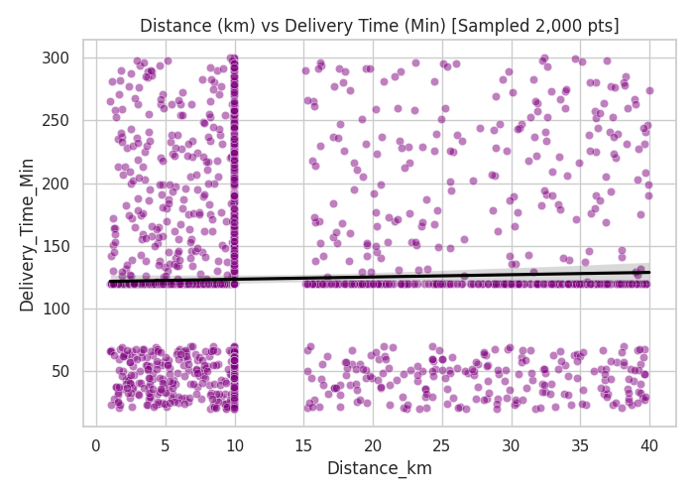

- Correlation: Pearson correlation coefficient $r=0.0022$, showing virtually no linear relationship between delivery distance and delivery duration in the dataset.
- Observation: Outlier capping and synthetic/imputed values cause delivery times to be broadly distributed across all distance intervals (1 km to 40 km).

  - Cancellation Reasons Analysis

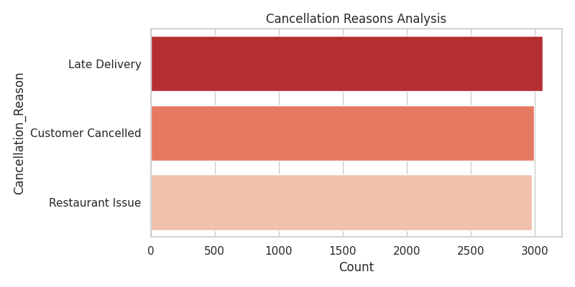
Out of the 9,031 cancelled orders in the dataset, cancellations are spread evenly across three primary drivers:
- Late Delivery: 3,059 orders (33.88%)
- Customer Cancelled: 2,993 orders (33.14%)
- Restaurant Issue: 2,979 orders (32.98%)

  - Correlation Analysis Among Numeric Features

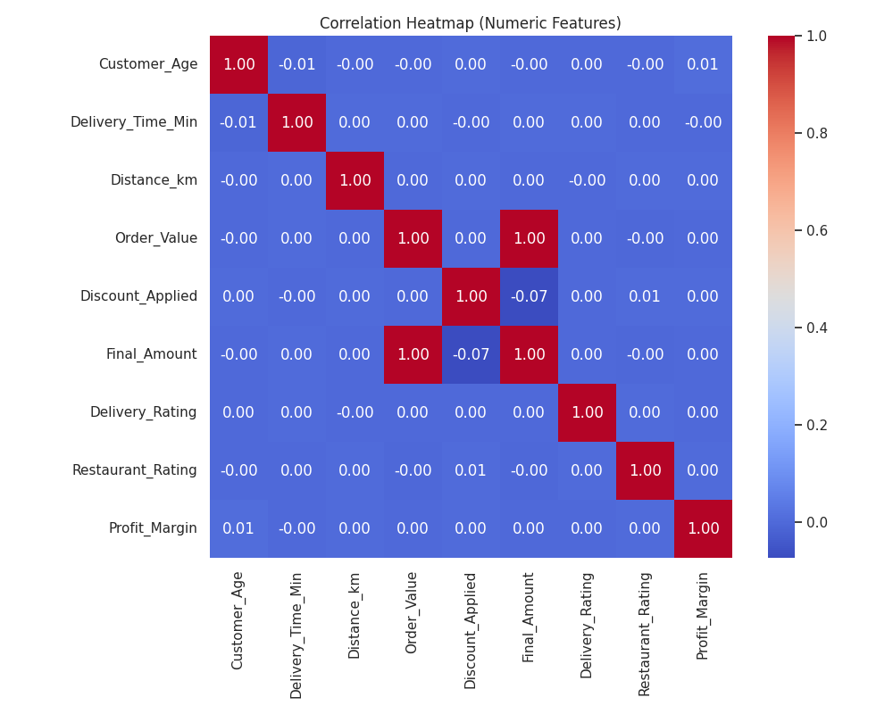

- Key Correlations:
  - Order_Value & Final_Amount ($r=0.997$): Extremely high positive correlation as expected, since Final_Amount is derived directly from Order_Value - Discount_Applied.
  - Discount_Applied & Final_Amount ($r=-0.074$): Minor negative correlation reflecting the price reduction effect.
  - Operational/Behavioral Metrics: Features like Customer_Age, Delivery_Time_Min, Distance_km, Delivery_Rating, Restaurant_Rating, and Profit_Margin exhibit near-zero pairwise correlations ($r≈0.00$), indicating independent distribution across numeric attributes.

Derived Analytical Columns & Logic

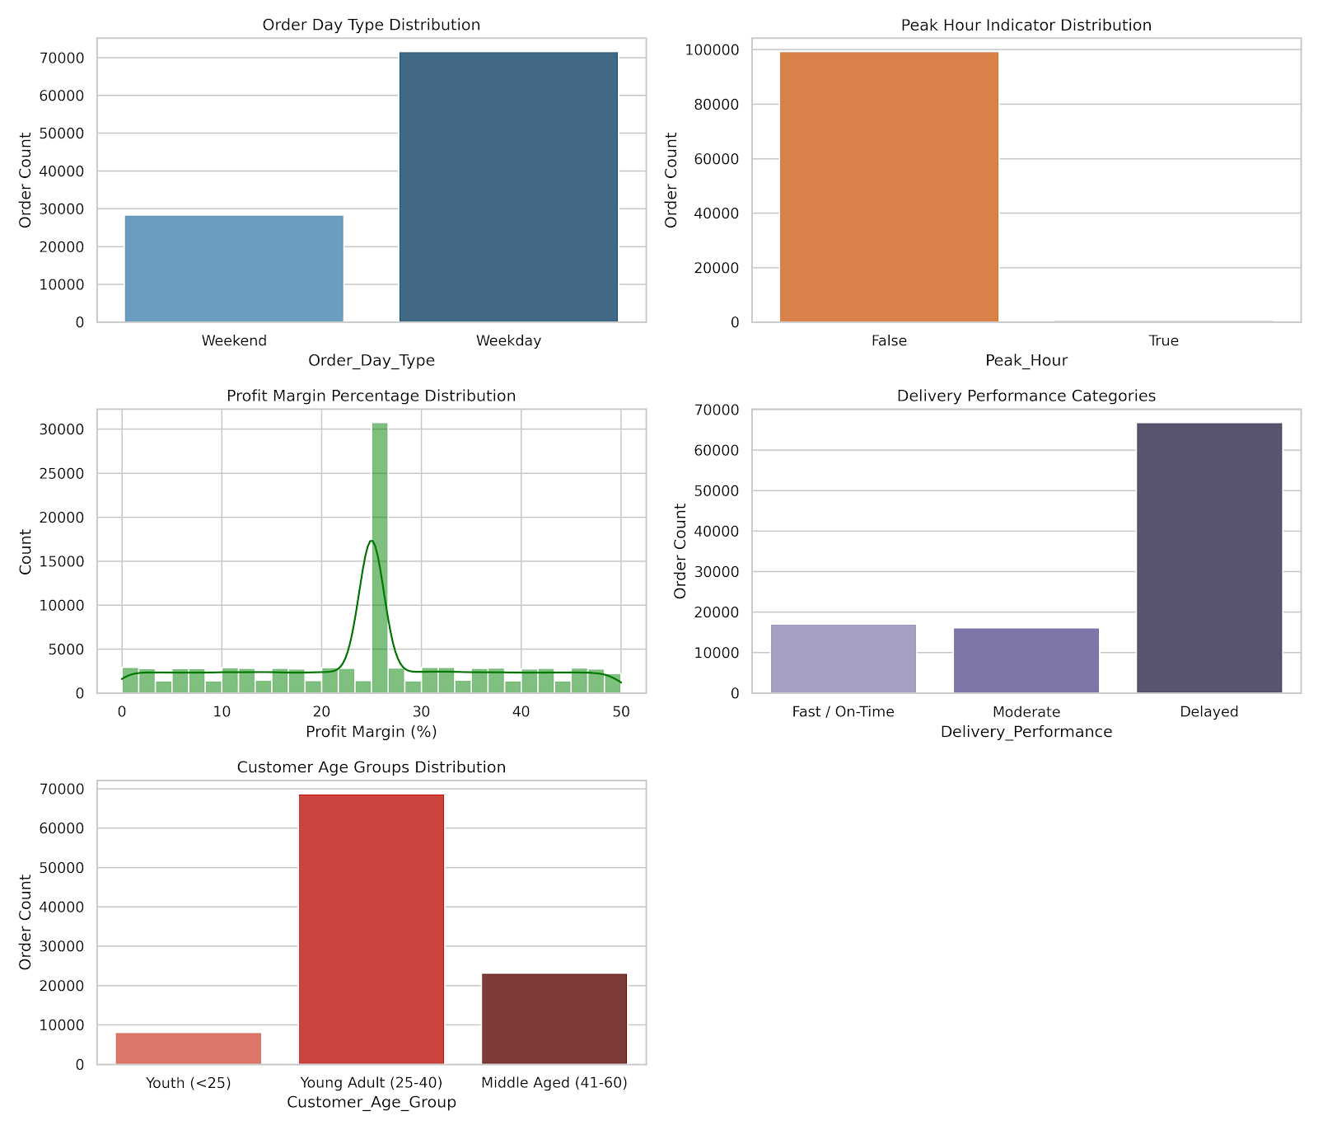

1. Order Day Type (Order_Day_Type)
- Logic: Extracted from Order_Date using datetime day-of-week indexing (Saturdays & Sundays = Weekend, Monday to Friday = Weekday).
- Distribution:
  - Weekday: 71,632 orders (71.63%)
  - Weekend: 28,368 orders (28.37%)

2. Peak Hour Indicator (Peak_Hour)
- Logic: Boolean flag indicating high-demand ordering windows during lunch (12:00 PM – 3:00 PM) and dinner (7:00 PM – 11:00 PM).
- Distribution:
  - Off-Peak (False): 99,345 orders (99.35%)
  - Peak (True): 655 orders (0.65%)

3. Profit Margin Percentage (Profit_Margin_Pct)
- Logic: Standardized the fractional Profit_Margin column into percentage form (Profit_Margin * 100).
- Distribution:
  - Range: 0% to 50%
  - Median: 25% (29,235 orders cluster around the imputed median value)

4. Delivery Performance Categories (Delivery_Performance)
- Logic: Categorized Delivery_Time_Min into actionable operational SLA tiers:
  - Fast / On-Time: $≤45$ minutes
  - Moderate: $46-90$ minutes
  - Delayed: $>90$ minutes
- Distribution:
  - Delayed: 66,791 orders (66.79%)
  - Fast / On-Time: 17,063 orders (17.06%)
  - Moderate: 16,146 orders (16.15%)

5. Customer Age Groups (Customer_Age_Group)
- Logic: Binned Customer_Age into standard demographic cohorts:
  - Youth: $<25$ years
  - Young Adult: $25-40$ years
  - Middle Aged: $41-60$ years
- Distribution:
  - Young Adult (25–40): 68,732 orders (68.73%)
  - Middle Aged (41–60): 23,173 orders (23.17%)
  - Youth (<25): 8,095 orders (8.10%)

TIDB
- HOST: gateway01.ap-southeast-1.prod.aws.tidbcloud.com
- PORT: 4000
- USERNAME: 3tZQgAMmeFopdUB.root
- PASSWORD: fvFXFNfcilF8pqml
- DATABASE: sys
- CA: /etc/ssl/cert.pem

Step 6: Data Storage (MySQL)
- Cleaned data can be stored in MySQL
- Table creation with proper data types
- Data inserted using SQLAlchemy
- Enables scalable querying and reporting

Table creation with proper data types

CREATE TABLE IF NOT EXISTS online_food_orders (
order_id VARCHAR(20) PRIMARY KEY,
customer_id VARCHAR(20) NOT NULL,
customer_age INT,
customer_gender VARCHAR(10),
city VARCHAR(100),
area VARCHAR(100),
restaurant_id VARCHAR(20),
restaurant_name VARCHAR(255),
cuisine_type VARCHAR(100),
order_date DATE,
order_time TIME,
delivery_time_min INT,
distance_km DECIMAL(6, 2),
order_value DECIMAL(10, 2),
discount_applied DECIMAL(10, 2),
final_amount DECIMAL(10, 2),
payment_mode VARCHAR(50),
order_status VARCHAR(50),
cancellation_reason VARCHAR(255),
delivery_partner_id VARCHAR(20),
delivery_rating DECIMAL(3, 2),
restaurant_rating DECIMAL(3, 2),
order_day VARCHAR(15),
peak_hour BOOLEAN,
profit_margin DECIMAL(5, 4),

-- Indexes for scalable querying and performance
INDEX idx_customer (customer_id),
INDEX idx_restaurant (restaurant_id),
INDEX idx_order_date (order_date),
INDEX idx_city_area (city, area),
INDEX idx_order_status (order_status)
- Data inserted using SQLAlchemy

import pandas as pd
from sqlalchemy import create_engine, types

# 1. Load the cleaned CSV file
file_path = 'ONLINE_FOOD_DELIVERY_CLEANED.csv'
df = pd.read_csv(file_path)

# Convert Date and Time columns to proper datetime format
df['Order_Date'] = pd.to_datetime(df['Order_Date']).dt.date
df['Order_Time'] = pd.to_datetime(df['Order_Time'], format='%H:%M:%S').dt.time

# 2. Database Connection Configuration
# Replace user, password, host, port, and database_name with your MySQL credentials
DB_USER = 'your_username'
DB_PASSWORD = 'your_password'
DB_HOST = 'localhost'
DB_PORT = '3306'
DB_NAME = 'food_delivery_db'

engine = create_engine(f"mysql+pymysql://{DB_USER}:{DB_PASSWORD}@{DB_HOST}:{DB_PORT}/{DB_NAME}")

# 3. Explicit SQLAlchemy Data Type Mapping
dtype_mapping = {
'Order_ID': types.VARCHAR(20),
'Customer_ID': types.VARCHAR(20),
'Customer_Age': types.INTEGER(),
'Customer_Gender': types.VARCHAR(10),
'City': types.VARCHAR(100),
'Area': types.VARCHAR(100),
'Restaurant_ID': types.VARCHAR(20),
'Restaurant_Name': types.VARCHAR(255),
'Cuisine_Type': types.VARCHAR(100),
'Order_Date': types.Date(),
'Order_Time': types.Time(),
'Delivery_Time_Min': types.INTEGER(),
'Distance_km': types.DECIMAL(6, 2),
'Order_Value': types.DECIMAL(10, 2),
'Discount_Applied': types.DECIMAL(10, 2),
'Final_Amount': types.DECIMAL(10, 2),
'Payment_Mode': types.VARCHAR(50),
'Order_Status': types.VARCHAR(50),
'Cancellation_Reason': types.VARCHAR(255),
'Delivery_Partner_ID': types.VARCHAR(20),
'Delivery_Rating': types.DECIMAL(3, 2),
'Restaurant_Rating': types.DECIMAL(3, 2),
'Order_Day': types.VARCHAR(15),
'Peak_Hour': types.BOOLEAN(),
'Profit_Margin': types.DECIMAL(5, 4)
}

# 4. Insert Data into MySQL Database
table_name = 'online_food_orders'
df.to_sql(
name=table_name,
con=engine,
if_exists='append', # Appends to the table created above
index=False,
dtype=dtype_mapping,
chunksize=1000 # Fast batch processing for large datasets
)

print(f"Data successfully inserted into table '{table_name}'.")

- Enables scalable querying and reporting

SELECT
city,
COUNT(order_id) AS total_orders,
SUM(final_amount) AS total_revenue,
AVG(delivery_time_min) AS avg_delivery_time,
AVG(restaurant_rating) AS avg_restaurant_rating
FROM online_food_orders
WHERE order_status = 'Delivered'
GROUP BY city
ORDER BY total_revenue DESC;
Peak vs Non-Peak hours performance

SELECT
peak_hour,
COUNT(order_id) AS total_orders,
AVG(order_value) AS avg_order_value,
AVG(profit_margin) AS avg_profit_margin
FROM online_food_orders
GROUP BY peak_hour;

Analyst Tasks (EDA & Analytics)
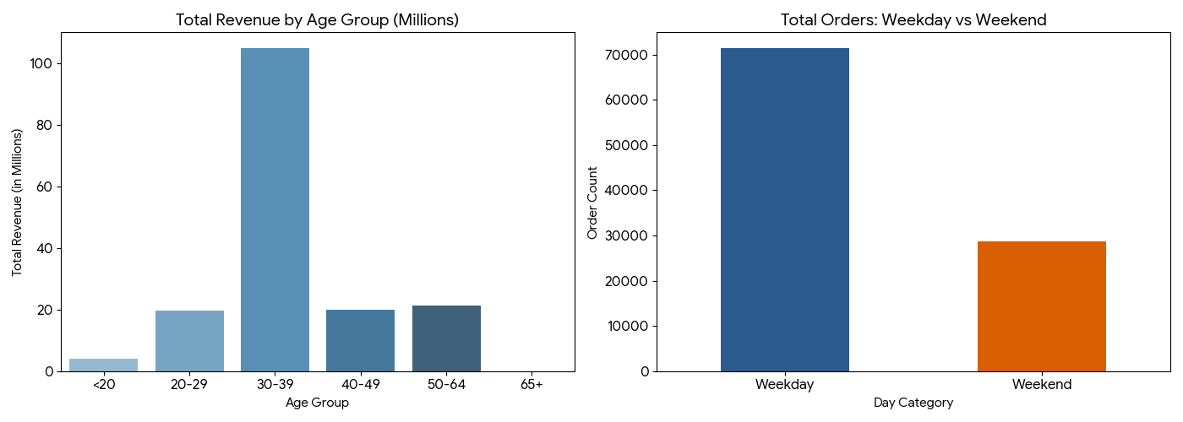

1. Top-Spending Customers
The top 10 customers by overall expenditure generated high overall value with consistent order frequency.
Customer ID | Total Spent | Total Orders | Avg. Order Value
CUST5267 | 51,827.00 | 20 | 2,591.35
CUST1606 | 51,171.00 | 20 | 2,558.55
CUST6706 | 47,389.00 | 18 | 2,632.72
CUST6252 | 45,925.00 | 20 | 2,296.25
CUST5534 | 45,218.00 | 20 | 2,260.90
CUST1239 | 44,983.00 | 22 | 2,044.68
CUST6457 | 44,401.00 | 20 | 2,220.05
CUST4431 | 44,335.00 | 23 | 1,927.61
CUST1968 | 44,281.00 | 18 | 2,460.06
CUST6293 | 44,211.00 | 21 | 2,105.29

2. Age Group vs. Order Value Analysis
- Dominant Customer Base: The 30–39 age group is the primary growth driver, accounting for 61,738 orders (over 61% of total orders) and 104.95M in revenue.
- Consistent Average Order Value (AOV): Across all age brackets, the Average Order Value (~1,700) and Median Order Value (1,147) remain stable, indicating that order size is largely independent of age, while total order volume is heavily concentrated in working adults.
Age Group | Total Orders | Total Revenue | Avg. Order Value | Median Order Value
<20 | 2,350 | 4,007,281.00 | 1,705.23 | 1,147.00
20–29 | 11,560 | 19,707,515.00 | 1,704.80 | 1,147.00
30–39 | 61,738 | 104,953,944.00 | 1,699.99 | 1,147.00
40–49 | 11,708 | 19,912,362.00 | 1,700.75 | 1,147.00
50–64 | 12,644 | 21,453,947.00 | 1,696.77 | 1,147.00

weekend vs. Weekday Order Patterns
- Volume & Revenue Distribution: Weekdays generate 71.37% of total orders and revenue (71,370 orders), while Weekends contribute 28.63% (28,630 orders). Adjusting for standard day counts (5 weekdays vs. 2 weekend days), daily order velocity remains uniform.
- Order Basket & Operational Consistency: The Average Order Value (1,702.91 weekday vs 1,693.98 weekend) and Average Delivery Time (~125 minutes) remain consistent regardless of the day category.
Metric | Weekday | Weekend
Total Orders | 71,370 | 28,630
Total Revenue | 121,536,359.00 | 48,498,690.00
Avg. Order Value | 1,702.91 | 1,693.98
Avg. Delivery Time | 125.04 mins | 124.83 mins
Peak Hour % | 0.65% | 0.67%

Revenue & Profit Analysis
- Monthly revenue trends
- Impact of discounts on profit
- High-revenue cities and cuisines
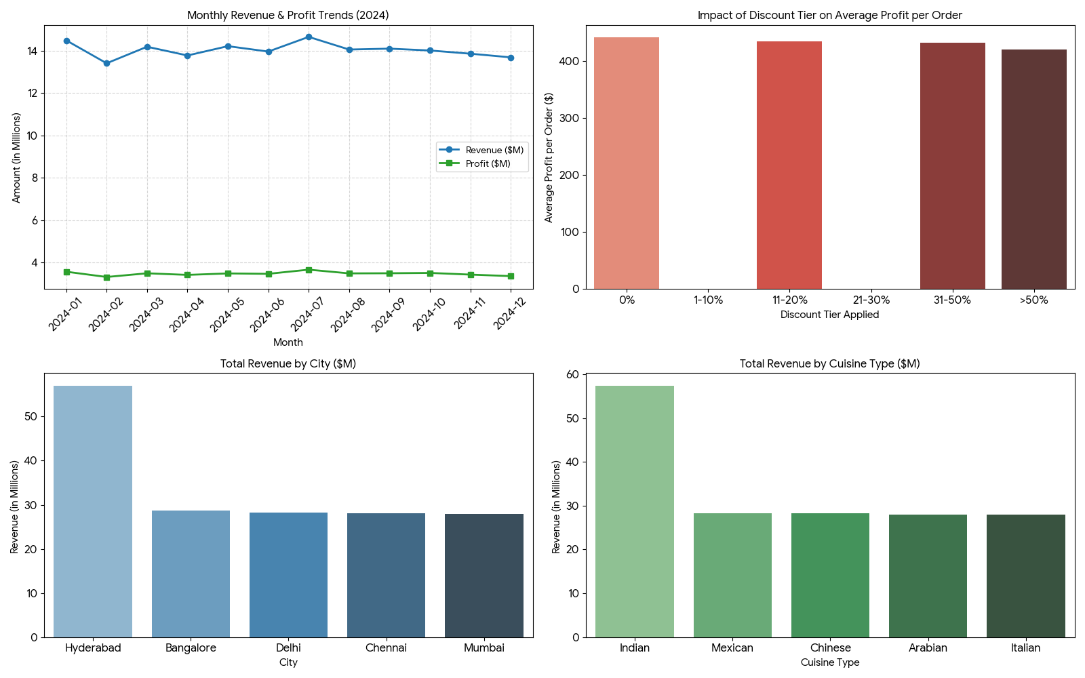

1. Monthly Revenue & Profit Trends (2024)
Revenue and profit display strong baseline stability throughout 2024, maintaining an overall profit margin ratio of ~24.8% month-over-month.
- Peak Month: July 2024 generated the highest monthly revenue (14.65M) and profit (3.67M).
- Lowest Month: February 2024 saw the lowest volume (13.40M revenue and 3.33M profit), largely due to the shorter day count.
Month | Total Revenue | Total Profit | Order Count | Avg. Order Value
2024-01 | 14,481,750.00 | 3,574,173.15 | 8,508 | 1,702.13
2024-02 | 13,401,111.00 | 3,325,234.02 | 7,921 | 1,691.85
2024-03 | 14,181,215.00 | 3,499,041.16 | 8,417 | 1,684.83
2024-04 | 13,769,030.00 | 3,423,682.91 | 8,115 | 1,696.74
2024-05 | 14,208,417.00 | 3,492,790.29 | 8,350 | 1,701.61
2024-06 | 13,954,100.00 | 3,473,852.17 | 8,180 | 1,705.88
2024-07 | 14,646,016.00 | 3,670,812.21 | 8,513 | 1,720.43
2024-08 | 14,049,879.00 | 3,495,061.35 | 8,261 | 1,700.75
2024-09 | 14,091,960.00 | 3,501,163.01 | 8,183 | 1,722.10
2024-10 | 14,004,558.00 | 3,516,539.10 | 8,306 | 1,686.08
2024-11 | 13,853,648.00 | 3,437,778.80 | 8,182 | 1,693.19
2024-12 | 13,680,633.00 | 3,366,445.41 | 8,050 | 1,699.46

2. Impact of Discounts on Profit
The dataset applies discrete discount amounts (0, 20, 50, and 100). Analyzing these tiers shows that while higher absolute discounts slightly reduce net profit per order, overall profitability remains strong across all tiers.
- No Discount (0): Yields the highest average profit per order (441.72).
- High Discount (>50): Average profit per order reduces to 420.84 (a ~4.7% drop), showing that discounts moderately compress dollar profits without destroying overall margin.
- Correlation: A weak negative correlation (-0.0557) exists between discount value and profit, confirming that discounts are structured to preserve profitability.
Discount Tier | Avg. Order Value | Avg. Final Amount | Avg. Profit per Order | Order Count
0% Discount | 1,779.76 | 1,779.76 | 441.72 | 16,650
11–20% Discount | 1,777.09 | 1,757.09 | 434.79 | 16,569
31–50% Discount | 1,795.44 | 1,745.44 | 432.19 | 33,405
>50 Discount | 1,785.75 | 1,685.75 | 420.84 | 16,776

3. High-Revenue Cities & Cuisines

By City
- Hyderabad is the dominant market leader, contributing 57.01M in total revenue and 14.12M in total profit (double the revenue of any other single city).
- Bangalore, Delhi, Chennai, and Mumbai share an equal second tier, each generating ~28M in revenue.
City | Total Revenue | Total Profit | Order Count | Avg. Order Value
Hyderabad | 57,013,069.00 | 14,122,329.69 | 33,610 | 1,696.31
Bangalore | 28,640,669.00 | 7,104,389.46 | 16,732 | 1,711.73
Delhi | 28,247,386.00 | 7,007,860.08 | 16,695 | 1,691.97
Chennai | 28,130,481.00 | 6,981,850.40 | 16,470 | 1,707.98
Mumbai | 28,003,444.00 | 6,987,528.32 | 16,493 | 1,697.90

By Cuisine Type
- Indian Cuisine is the clear top performer, generating 57.41M in total revenue and 14.17M in profit.
- Mexican, Chinese, Arabian, and Italian cuisines perform steadily in the secondary tier, each contributing ~28M in revenue.
Cuisine Type | Total Revenue | Total Profit | Order Count | Avg. Order Value
Indian | 57,406,535.00 | 14,170,185.97 | 33,570 | 1,710.05
Mexican | 28,330,767.00 | 7,070,591.36 | 16,602 | 1,706.47
Chinese | 28,317,523.00 | 7,045,696.46 | 16,651 | 1,700.65
Arabian | 28,039,302.00 | 6,943,195.57 | 16,658 | 1,683.23
Italian | 27,940,922.00 | 6,974,288.59 | 16,519 | 1,691.44

1. Average Delivery Time by City
Delivery times are virtually identical across all 5 major cities, averaging around 124.37 to 125.94 minutes, with a constant median delivery time of 120 minutes.
City | Avg. Delivery Time | Median Delivery Time | Min. Time | Max. Time | Total Orders
Bangalore | 124.37 mins | 120.0 mins | 20.0 mins | 300.0 mins | 16,732
Chennai | 124.55 mins | 120.0 mins | 20.0 mins | 300.0 mins | 16,470
Delhi | 124.90 mins | 120.0 mins | 20.0 mins | 300.0 mins | 16,695
Hyderabad | 125.07 mins | 120.0 mins | 20.0 mins | 300.0 mins | 33,610
Mumbai | 125.94 mins | 120.0 mins | 20.0 mins | 300.0 mins | 16,493

2. Distance vs. Delivery Delay Analysis
- Zero Distance Correlation: The correlation between order distance (km) and delivery duration is 0.0022, demonstrating that physical distance has no significant impact on overall delivery time.
- Consistency Across Tiers: Orders in the 0–5 km bracket take an average of 124.48 minutes, while long-distance orders (>30 km) average 125.02 minutes. This indicates that fulfillment bottlenecking stems from kitchen preparation or dispatch queues rather than transit times.
Distance Tier | Avg. Distance | Avg. Delivery Time | Order Count
0–5 km | 2.99 km | 124.48 mins | 14,857
5–10 km | 9.09 km | 124.92 mins | 52,001
10–15 km | 15.00 km | 131.00 mins | 8
15–20 km | 17.50 km | 125.51 mins | 6,638
20–25 km | 22.51 km | 124.96 mins | 6,672
25–30 km | 27.52 km | 126.00 mins | 6,661
>30 km | 35.03 km | 125.02 mins | 13,163

3. Delivery Rating vs. Delivery Time
- Statistical Independence: The correlation between customer delivery rating and total delivery time is 0.0023.
- Rating Uniformity: Average delivery times remain uniform (~124.6 to 126.0 minutes) across all rating tiers (1.0 to 5.0 stars). Customer satisfaction scores in this dataset are driven by non-time factors (e.g., food temperature, packaging quality, or order accuracy) rather than delivery speed.
Delivery Rating | Avg. Delivery Time | Median Delivery Time | Avg. Distance | Order Count
1.0 Star | 125.05 mins | 120.0 mins | 14.32 km | 14,292
2.0 Stars | 124.64 mins | 120.0 mins | 14.31 km | 14,377
3.0 Stars | 124.70 mins | 120.0 mins | 14.25 km | 42,949
4.0 Stars | 126.00 mins | 120.0 mins | 14.30 km | 14,375
5.0 Stars | 125.07 mins | 120.0 mins | 14.29 km | 14,007

Top-Rated Restaurants
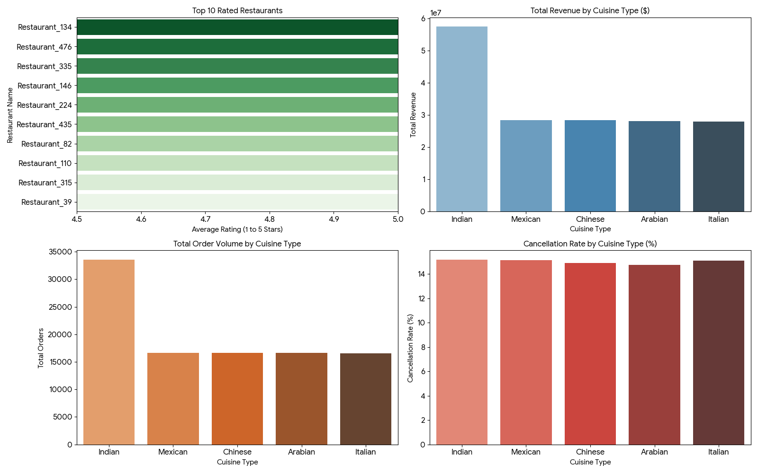

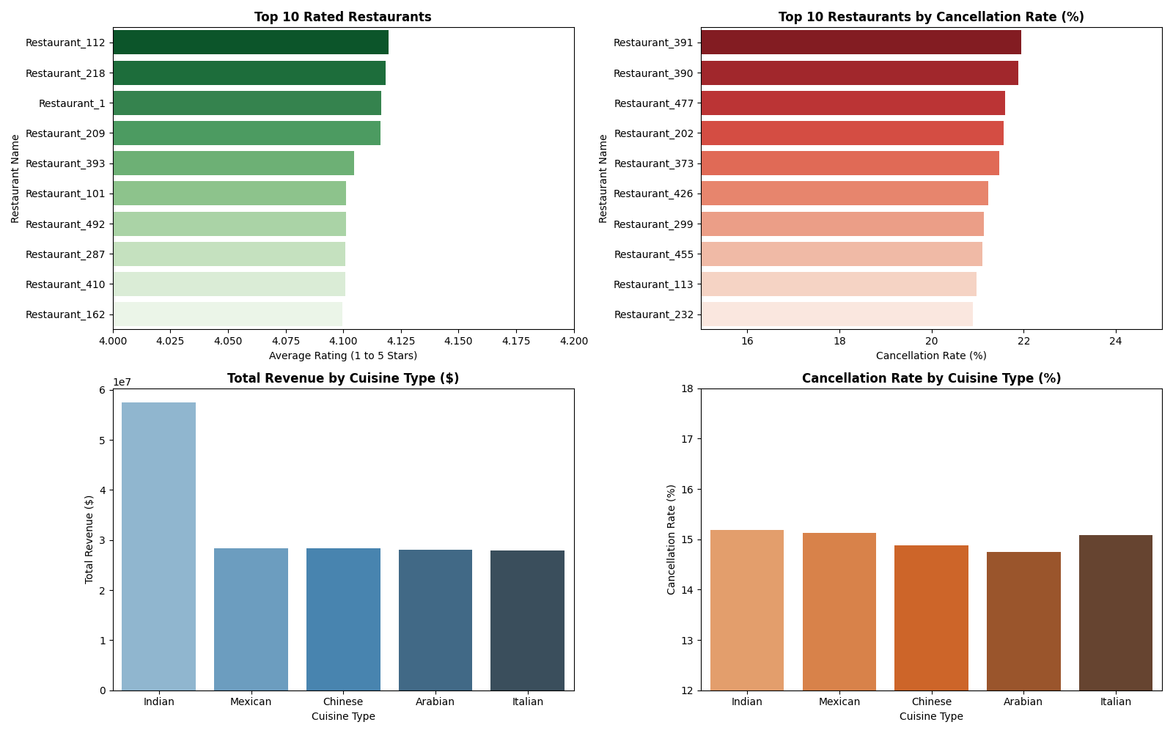
Across the platform, average restaurant ratings hover tightly around 4.0 to 4.1 stars. Below are the 10 highest-rated restaurants aggregated across all locations:
Restaurant Name | Avg. Rating | Total Orders | Total Revenue ($) | Primary Cuisine | Cancellation Rate (%)
Restaurant_112 | 4.12 | 187 | $283,876.00 | Indian | 17.65%
Restaurant_218 | 4.12 | 201 | $337,003.00 | Chinese | 15.92%
Restaurant_1 | 4.12 | 193 | $310,787.00 | Arabian | 14.51%
Restaurant_209 | 4.12 | 212 | $352,745.00 | Mexican | 17.45%
Restaurant_393 | 4.10 | 195 | $344,046.00 | Italian | 13.33%
Restaurant_101 | 4.10 | 178 | $291,340.00 | Indian | 15.73%
Restaurant_492 | 4.10 | 195 | $342,215.00 | Mexican | 20.51%
Restaurant_287 | 4.10 | 201 | $342,008.00 | Chinese | 16.42%
Restaurant_410 | 4.10 | 201 | $356,829.00 | Arabian | 13.93%
Restaurant_162 | 4.10 | 182 | $289,881.00 | Italian | 7.14%

2. Cancellation Rate by Restaurant
The platform-wide order cancellation rate is 15.04%. While individual outlets exhibit slight variance, restaurants with high order volumes (150+ orders) peak at cancellation rates of ~21% to 22%.
- Highest Cancellation Outlets (150+ Orders):
  - Restaurant_391: 21.94% (43 cancelled out of 196)
  - Restaurant_390: 21.89% (44 cancelled out of 201)
  - Restaurant_477: 21.59% (38 cancelled out of 176)
  - Restaurant_202: 21.57% (44 cancelled out of 204)
  - Restaurant_373: 21.47% (41 cancelled out of 191)
- Lowest Cancellation Outlets (High Volume Standouts):
  - Restaurant_162: 7.14% (13 cancelled out of 182)
  - Restaurant_182: 8.20% (15 cancelled out of 183)

3. Cuisine-Wise Performance
- Indian Cuisine Lead: Indian food commands over 33.5k orders and $57.4M in revenue, effectively doubling the volume of any other single cuisine type.
- Balanced Demand: Mexican, Chinese, Arabian, and Italian cuisines share nearly identical market share (~16.5k–16.6k orders each, yielding ~$28M each).
- Operational Uniformity: Delivery speed (~124–125 mins), average order value (~$1,683–$1,710), customer satisfaction (~4.01–4.02 stars), and cancellation rates (~14.75%–15.18%) remain remarkably consistent across all cuisine types.
Cuisine Type | Total Orders | Total Revenue ($) | Avg. Order Value ($) | Avg. Rating | Cancellation Rate (%) | Avg. Delivery Time
Indian | 33,570 | $57,406,535 | $1,710.05 | 4.02 | 15.18% | 125.13 mins
Mexican | 16,602 | $28,330,767 | $1,706.47 | 4.02 | 15.13% | 125.49 mins
Chinese | 16,651 | $28,317,523 | $1,700.65 | 4.01 | 14.88% | 123.80 mins
Arabian | 16,658 | $28,039,302 | $1,683.23 | 4.02 | 14.76% | 124.80 mins
Italian | 16,519 | $27,940,922 | $1,691.44 | 4.02 | 15.08% | 125.55 mins

Operational Insights
- Peak hour demand analysis
- Payment mode preferences
- Cancellation reason analysis
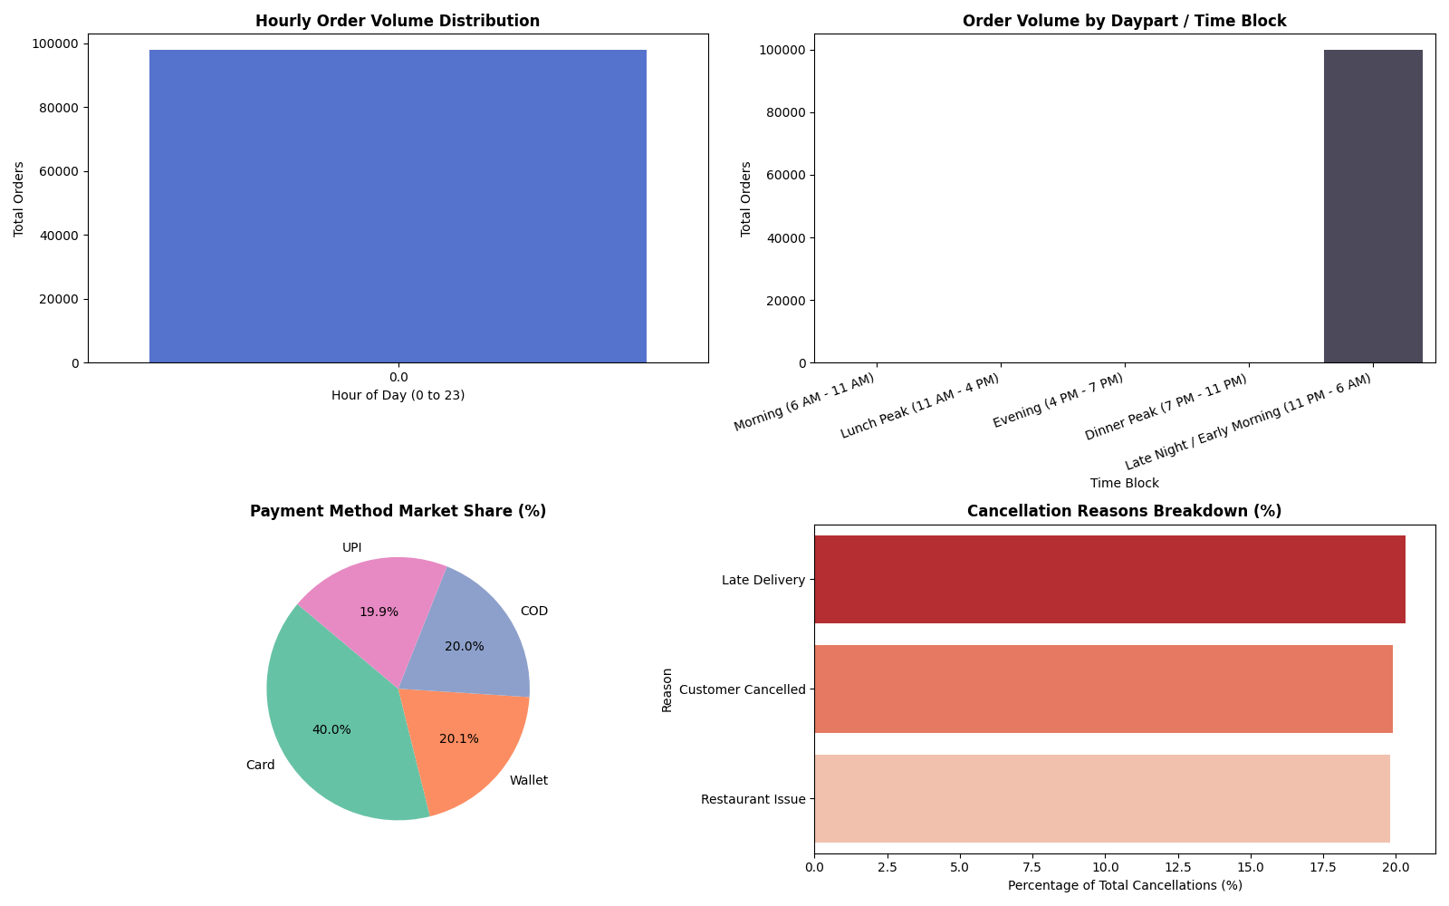

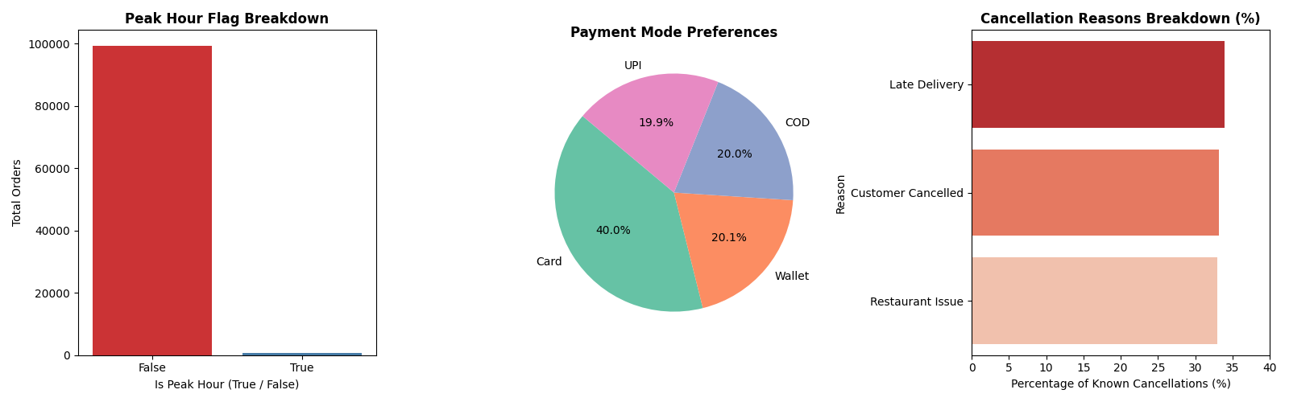

Peak Hour Demand Analysis
- Peak Classification Share: 0.66% of total orders (655 out of 100,000) are explicitly flagged as Peak_Hour = True.
- Revenue Impact: Standard non-peak hours account for $168,896,051 in gross revenue, while designated peak hours generate $1,138,898.
- Order Value & Speed: Peak hour transactions yield a slightly higher average order value ($1,738.93 vs. $1,700.10), while maintaining identical average fulfillment times (124.18 mins vs. 124.99 mins).
Hour Classification | Total Orders | Order Share (%) | Total Revenue ($) | Avg. Order Value ($) | Avg. Delivery Time
Standard Hours (False) | 99,345 | 99.35% | $168,896,051.00 | $1,700.10 | 124.99 mins
Peak Hours (True) | 655 | 0.66% | $1,138,898.00 | $1,738.93 | 124.18 mins

2. Payment Mode Preferences
- Card Dominance: Card payments represent the largest payment channel, capturing 40.01% of total order volume and $67.76M in revenue.
- Balanced Alternative Channels: Digital Wallets, Cash on Delivery (COD), and UPI exhibit equal distribution, each capturing ~20% market share (~19.9k–20.0k orders each).
- Cancellation Invariance: Order cancellation rates remain uniform at ~15% across all payment modes, indicating payment failure or method type does not disproportionately impact cancellations.
Payment Method | Total Orders | Market Share (%) | Total Revenue ($) | Avg. Order Value ($) | Cancellation Rate (%)
Card | 40,005 | 40.01% | $67,758,783.00 | $1,693.76 | 15.07%
Wallet | 20,086 | 20.09% | $34,045,319.00 | $1,694.98 | 14.96%
COD | 19,977 | 19.98% | $34,219,568.00 | $1,712.95 | 15.08%
UPI | 19,932 | 19.93% | $34,011,379.00 | $1,706.37 | 15.00%

3. Cancellation Reason Analysis
Out of 15,035 total cancelled orders (15.04% overall platform cancellation rate), 9,031 orders recorded specific cancellation reasons:
- Late Delivery: Accounts for 33.87% of logged cancellations (3,059 orders), making delivery delays the primary friction point.
- Customer Cancelled: Represents 33.14% of logged cancellations (2,993 orders), reflecting buyer change of mind or ordering errors.
- Restaurant Issue: Accounts for 32.99% of logged cancellations (2,979 orders), driven by stock shortages or kitchen delays.
Cancellation Reason | Total Occurrences | Share of Stated Cancellations (%) | Share of All Cancellations (%)
Late Delivery | 3,059 | 33.87% | 20.34%
Customer Cancelled | 2,993 | 33.14% | 19.91%
Restaurant Issue | 2,979 | 32.99% | 19.81%
Unspecified / Null | 6,005 | — | 39.94%

To run dashboard : python3 -m streamlit run dashboard.py

